Testing order management system API

Test 1: Get-Orders
- Description: GET request to get all orders from the order management system

- Correct response: Ok request (200) + List of orders with items, example:

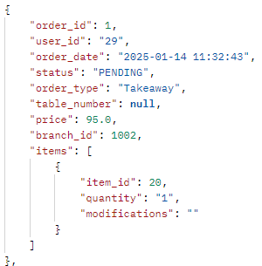
- Request: `http://127.0.0.1:5002//api/orders`
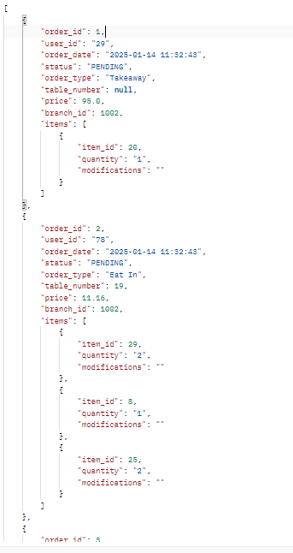
- Response:

- Test status: Passed

Test 2.a: Get-Orders-Extended
- Description: GET request to get all orders from the order management system with addition information about the items in an order

- Correct response: Ok request (200) + List of orders with items with added information in the item’s objects:

- Request: `http://0.0.0.0:5002//api/orders/extended`

- Response:
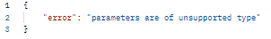

- Test status: Failed

Test 2.b: Get-Orders-Extended (fixed)
- Description: GET request to get all orders from the order management system with addition information about the items in an order with a fix for the failed test 2.a

- Fix: Brackets added to parameters section for query that gets the items data in the order

- Correct response: Ok request (200) + List of orders with items with added information in the item’s objects, example:
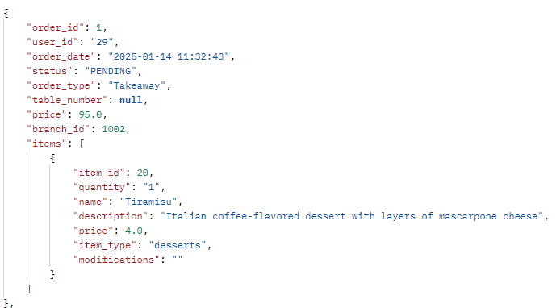

- Request: `http://0.0.0.0:5002//api/orders/extended`
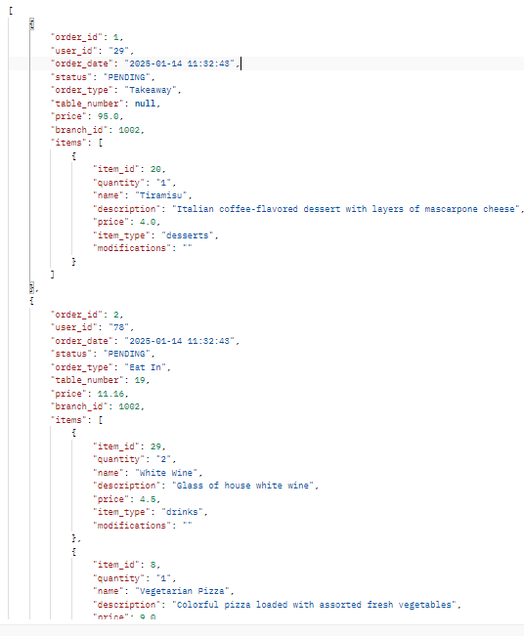
- Response:

- Test status: Passed

Test 3.a: Get-Orders-id
- Description: GET request to get one order from the order management system given an id

- Correct response: Ok request (200) + Orders object:

- Request: `http://127.0.0.1:5002//api/orders/1`

- Response:
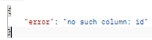
- Test status: Failed

Test 3.b: Get-Orders-id (fixed)
- Description: GET request to get one order from the order management system given an id

- Fix: Changed id to order_id in query on orders table

- Correct response: Ok request (200) + Orders object, example:
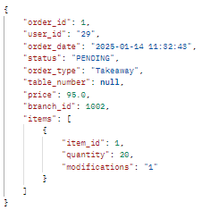
- Request: `http://127.0.0.1:5002//api/orders/1`

- Response:
- Test status: Passed

Test 4: Get-Orders-Date
- Description: Send GET request to get all orders within a given date range

- Correct response: Ok request (200) + List of order objects, example:
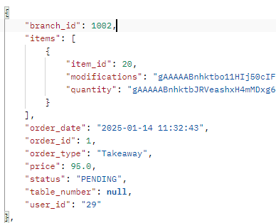
- Request: `http://127.0.0.1:5002//api/orders/date?start_date=2023-12-18&end_date=2026-12-29`

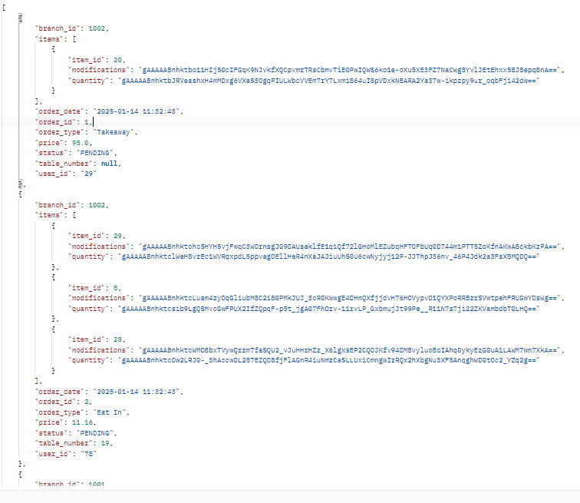
- Response:

- Test status: Passed - (However item information needs decryption)

Test 5: Get-Orders-Items-Quantity
- Description: Send GET request to get all items and their order quantity within a given date range

- Correct response: Ok request (200) + List of items object types with quantity, example:
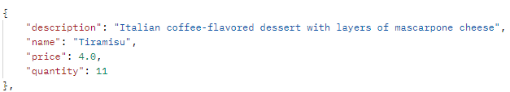
- Request: `http://0.0.0.0:5002//api/orders/items/quantity/date?start_date=2023-09-27&end_date=2026-12-29`
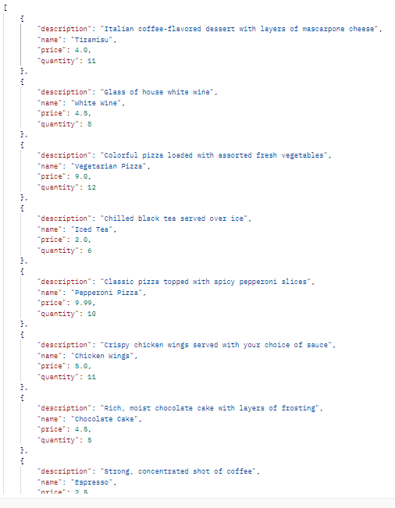
- Response:

- Test status: Passed

Test 6: Post-Order
- Description: POST request to save one order

- Correct response: Ok request (200) + Saved order information:

- Request: `http://127.0.0.1:5002/api/orders/create`+ body:
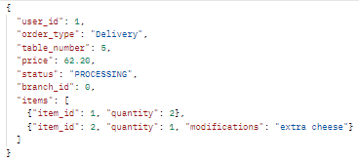

- Response:
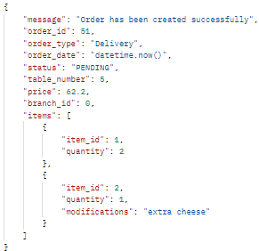
- Test status: Passed

Test 7: Delete-Order
- Description: DELETE request to remove an order from the database with a given id

- Correct response: Ok request (200) + Removed order conformation:

- Request: `http://127.0.0.1:5002/api/orders/1/delete`:

- Response:
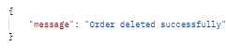
- Test status: Passed

Test 8.a: PUT-order-status
- Description: PUT request to update status attribute inside order with given id

- Correct response: Ok request (200) + Updated status conformation request:

- Request: `http://127.0.0.1:5002/api/orders/1/status` + body:
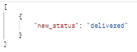
- Response:
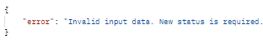
- Test status: Failed

Test 8.b: PUT-order-status
- Description: PUT request to update status attribute inside order with given id with changes made for fix

- Correct response: Ok request (200) + Updated status conformation request:

- Fix: Changed id and status to order_id and order_status in UPDATE query. Furthermore the Error check for the “new_status” attribute in the body is moved to after new_status variable assignment

- Request: `http://127.0.0.1:5002/api/orders/1/status` + body:
- Response:
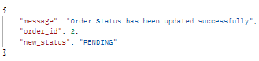
- Test status: Passed

Test 9: PUT-order-status
- Description: PUT request to update order items attribute inside order with given id

- Correct response: Ok request (200) + Updated status conformation request:

- Request: `http://127.0.0.1:5002/api/orders/2/items` + body:
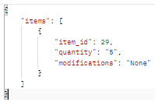
- Response:
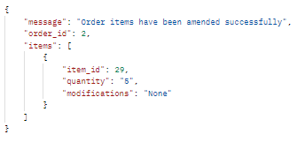
- Test status: Success

